
DISABLED AMERICAN VETERANS
Chapter 13
Post Office Box 639
Glen Burnie, MD 21061

___________________________________________________________________________________
Commander/Editor Aux. Commander Adjutant
Thom Unkle Sr. Annalee Mullenax Charles Claypool
(410) 766-0429/286-6647 (410) 255-3730 (410) 647-7434
____________________________________________________________________________________________________
Chapter meetings every 1st Thursday of the month at 7:00PM, 8068 Quarterfield Road, Severn, Maryland

January 2008 – March 2008

COMMANDER’S MESSAGE

Dear Comrades:
I hope you had a wonderful holiday season and I wish you the very best for a happy and healthy New Year. We have had a very good year this past year. We had a good Forget-Me-Not drive and the raffle drive has been the best response since I have been Commander. We have had over 30% responses – still ways to go for 100%, but we are improving. Our efforts at the Golden Corral on Ordinance Road in Glen Burnie was successful with over $8,000 raised in donations from the community, which placed this Golden Corral Restaurant and our chapter in first place in the state and in sixth place in the country for fund raising. I hope you had the opportunity to enjoy your free meal during the Golden Corral Veterans Appreciation Day on November 12. We are looking forward to an even more successful coming year. To do this, we need you to volunteer your time and also make contributions through the raffle drive.

And don’t let me forget, we need you to write or call or e-mail your congressman and senator to remind them and demand that they support unlimited VA Funding for all veterans. No matter which state you live in, this is a Federal Government issue and needs everyone’s support.

I’m looking forward to meeting all our members in the coming year. Happy New Year!

For God, Country and the DAV

Thom
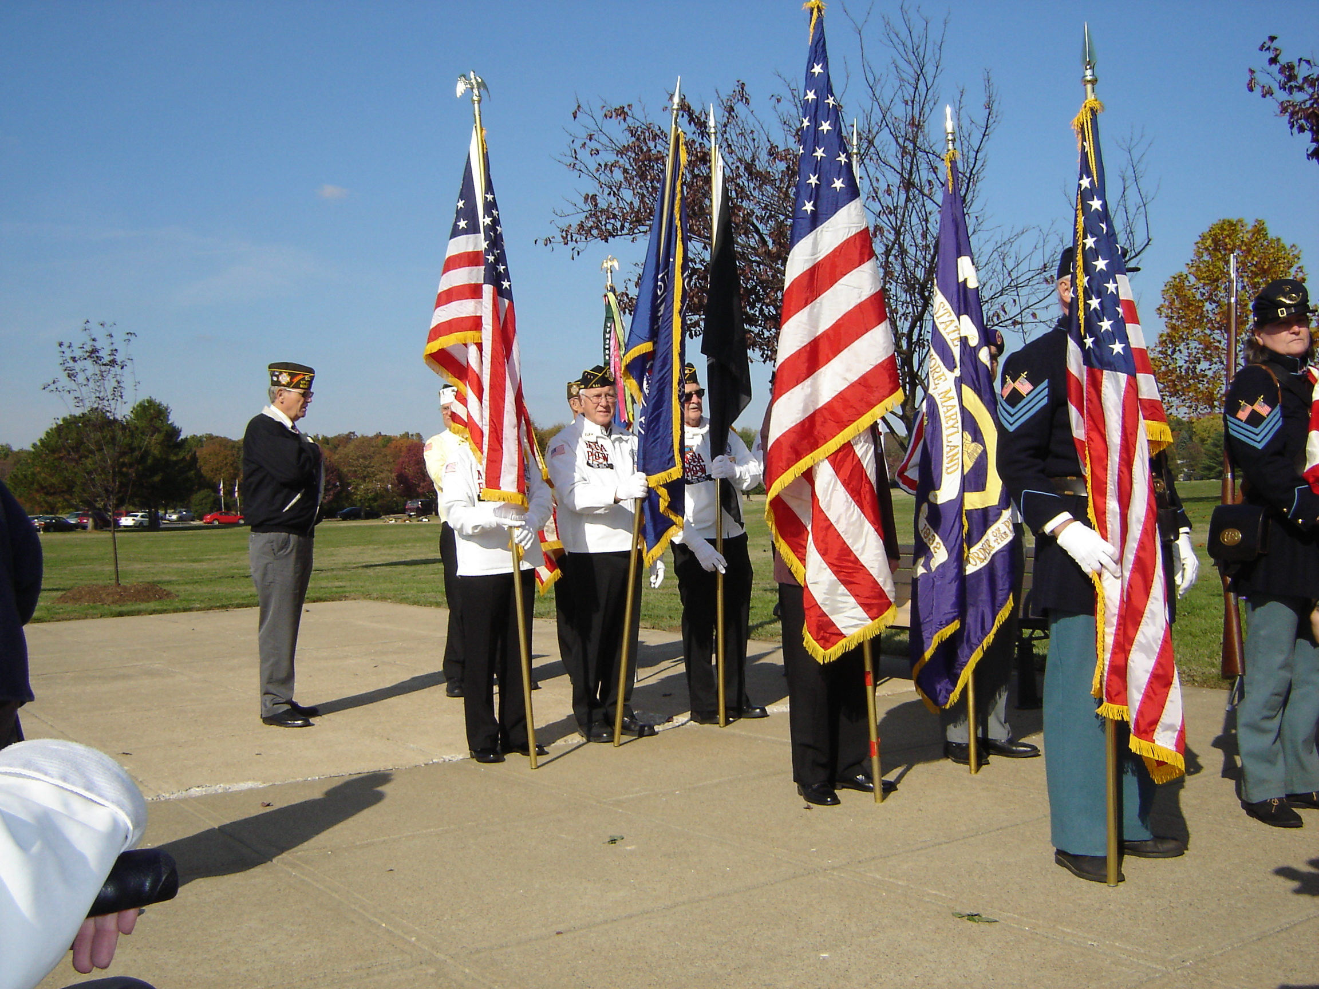
Events
Jan. 3, 2008 General Meeting, 7:00pm
Jan 24, 2008 Executive Meeting, 7:00pm
Feb.7, 2008 General Meeting, 7:00pm
Feb. 14, 2008 Valentine’s Day
Feb. 18, 2008 Presidents’ Day, VA clinic closed
Feb. 28, 2008 Executive Meeting, 7:00pm
Mar. 6, 2008 General Meeting, 7:00pm
Mar. 27, 2007 Executive Meeting, 7:00pm

2007 Veterans Day at Crownsville VA Cemetery

Chaplains Corner
Pray for our Marines and all service members serving in Iraq and around the world. May our Lord guide and protect them. Visit a veteran in the hospital. Pray for the families of our departed chapter members and for members who lost their spouses.
(Johnny Hall)

DAVA Unit Commander’s Message

Hello unit members:

As always, we had a great time at our Christmas party. Tom Baldwin did a great job again in helping Santa Claus (Wayne Godwin).
We also enjoyed the delicious spiced apple cakes from Gloria Baldwin. I hope you had a chance to spend some time with your family during the holiday season. We had a very successful year in our fund raising efforts and being able to donate funds to veterans’ hospitals and clinics. We also donated some money to the Fisher House and the USO at BWI to assist soldiers returning from the Middle East battlefields. Please try to keep in touch with our active members and check on them when they are absent or if they are sick. We try to help members who are not in the best of health by calling them to cheer them up or to find out if they have any special needs.

Wishing you the best of health and much happiness in the new year of 2008!

DAVA UNIT COMMANDER
Annalee Mullenax

Service Officer Report:

Suicide Prevention

Every suicide in America is a tragedy. VA cares about each veteran and their physical and mental health. We have more than 10,000 mental health workers who have dedicated themselves to helping veterans cope with the issues and crises they face. We operate a veteran suicide hotline which is available 24 hours a day, seven days a week, to help any veteran in need. That number is 1-800-273-TALK (8255). VA has suicide prevention coordinators at each of our VA Medical Centers. VA strongly encourages veterans who may be considering harming themselves in some way to seek treatment from VA or other health care providers in their communities. Our people are there to help during a crisis. VA's care and treatment works and is available for veterans with PTSD, depression and other mental health problems. VA operates the largest mental health care system in the country, spending $3 billion each year on its mental health programs, and has taken several measures to increase its mental health services in recent years. Those include new programs bringing mental health into primary care, intensified rehabilitation for those with serious mental illnesses, and expanded programs for homeless veterans and those with substance abuse problems.
(Department of Veterans Affairs)

Acting Secretary of Veterans Affairs Gordon H. Mansfield said the Department of Veterans Affairs (VA) plans to expand its efforts to prevent and control diabetes as part of an ongoing campaign to help veterans eat healthy, watch their weight and stay physically active.
“With over 25 percent of VA patients living with diabetes, it is important to find ways to bring this disease under control,” said Mansfield. “VA is doing more than ever to educate our veterans, research this disease and provide the type of specialized care that diabetes demands.”
Mansfield noted the Department has provided diabetic care to 70,000 veterans in more than 200,000 hospital and clinic visits since 2005.
Mansfield said VA plans to keep expanding its diabetes awareness effort as part of the Department’s broader HealthierUS Veterans campaign. Last year, television stations around the nation aired more than 3,000 VA-produced broadcasts about eating healthy and staying active. The Department held a symposium for health care professionals in Washington, D.C., and several public events around the country to inform veterans of the dangers of diabetes.
Annual evaluations of veterans with diabetes show small but continuing improvements in tested levels of blood sugar, LDL cholesterol and blood pressure with treatment, including weight management.
VA’s tele-health program allows patients with diabetes to monitor and transmit their blood pressure and blood glucose levels from home to VA facilities, thus improving their access to care and allowing them to take control of their own health through improved communication from home with their health care providers.
VA’s research programs include centers investigating insulin resistance, vascular damage and obesity, pre-clinical studies of new agents to prevent and treat diabetes and clinical trials of new ways to prevent kidney damage.
Other VA research is seeking ways to reduce diabetes complications that lead to disability, focusing on preventing loss of limbs and avoiding obesity among paraplegic patients likely to gain weight due to reduced movement. VA researchers also are examining the interplay between genetics and the environment in determining glucose metabolism and weight gain or loss.
Some veterans with diabetes qualify for VA disability compensation. Those veterans must have a diagnosis of diabetes and evidence that it began or was aggravated during active duty or within one year of release from duty. Since 2001, veterans who served in Vietnam and later developed adult-onset (Type 2) diabetes have been eligible for disability compensation. This policy affecting Vietnam veterans is an outgrowth of research into the effects of Agent Orange.
Department of Veterans Affairs)
More chapter news and information:

Walter Reed Army Medical Center officials want to remind those individuals who want to show their appreciation through mail to include packages, letters, and holiday cards addressed to 'Any Wounded Soldier' or 'A Recovering American Soldier' that Walter Reed cannot accept these packages in support of the decision by then Deputy Undersecretary of Defense for Transportation Policy in 2001. This decision was made to ensure the safety and well being of patients and staff at medical centers throughout the Department of Defense.
In addition, the U.S. Postal Service is no longer accepting "Any Service Member" or "A Recovering American Soldier" letters or packages. Mail to "Any Service Member" that is deposited into a collection box will not be delivered.

DAV Chapter 13 has a new website with updated information and photos. Please look at www.davmembersportal.org/chapters/md/13

POC: Pete Schwarz (webmaster).

Help us in our fund-raising effort with your donation!
DAV CHAPTER 13, GLEN BURNIE, MD

BUILDING BETTER LIFES FOR AMERICA’S DISABLED VETERANS

Those who would give up essential liberty to purchase a little temporary safety deserve neither liberty nor safety.

Benjamin Franklin

